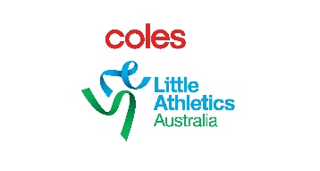

2020 COLES Little athletics AUSTRALIA
NATIONAL CAMP – Children with Disability Nomination form
State
Athletes name
DOB
2019-2020 LA Registered | Yes or No
Gender
Disability
Primary carer information: Name:
Email:
Mobile:
Classification
(please indicate option below if not classified)
In the process of being classified Yes
Still need to be classified Yes
Event/s | 1.
 | 2.
 | 3.
Result/s  (Result and event where achieved) | 1.
 | 2.
 | 3.
Short (no more than 100 words) statement setting out your journey in athletics so far, including any barriers you have faced, your goals and aspirations for the future.

Nomination to be completed and returned to Little Athletics Australia via your State Association.

