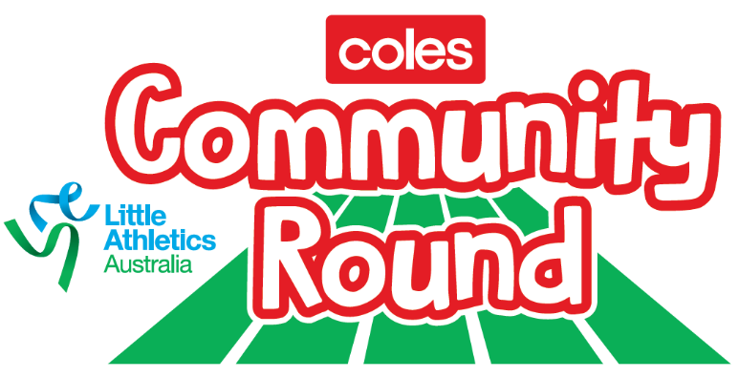

COLES-THEMED GAMES AND ACTIVITIES
Activity | Description | Equipment/space needed | Suggested time
Banana Says | “Banana Says” – similar to “Simon Says.” Have an adult or leader dress up as a banana and kids have to follow what the banana says rather than what they do, e.g. “Banana Says do 10 star jumps,” “Banana Says touch the ground” - If they get it wrong they will have sit out until there’s one person left | Dedicated area, depending on group size, marked out by cones.  Leader in a banana suit | 5 – 10 minutes
Banana Tag | Similar to “Scarecrow tiggy” – one person in a banana suit is “it”. If you get tagged by the banana, you have to stand like a banana with your arms above your head and hands together like a peeled banana. You can be “unpeeled” by another player who unpeel your arms from above your head one at a time. Game stops when everyone turns into a banana.  Extension: Progressively add in more banana taggers in banana suits | Dedicated area, depending on group size, marked out by cones.  Leader in a banana suit | 5 – 10 minutes
Fruit Salad | Divide into two teams with kids facing each other. They need to be sitting down with their feet touching. Give each kid from one line the name of a fruit (except banana). The person opposite will share the name of their fruit (optional – kids can choose their own fruit). Call one of the fruits, e.g apples. The two kids named apples must hurdle over the legs of the other kids then go around the back of their teams and sit back in their original positions. One point is awarded to the kid/team who returns first  Extension –  Place equal number of baskets of bananas behind each team. If you call “Bananas”, this means all fruits must get up, run to retrieve a banana and return to position. The team to have all fruits back to starting position first wins. | Dedicated area, depending on group size, marked out by cones.  Bananas  2 Coles baskets  Cones to identify starting positions | 10 minutes
Rob the nest | Kids divided into 4 teams of 6 and are numbered off 1 to 6 in each team (or however many in the group).  Teams are set up in a corner of a square with an empty basket in their corner.  Place a basket full of bananas in the middle of the square.  Leader calls out a number. The kid with that number in each team have to take one banana from the basket in the middle to their team’s basket. Then another number is called and they get a banana from the middle basket.  When all the bananas are gone from the middle, teams can then steal from other teams with one person allowed to run from each team at a time. Teams are not allowed to guard their baskets. The team with the most bananas wins. | 5 Coles baskets  Bananas | 15 minutes
Banana Shuttle Relay | Kids are divided into 4 or 5 teams of 5.  In each group, two children stand at one end of the lane (one behind the other), three stand about 20-30m opposite them in the same lane. The child at the front of the line (in the line with most kids) is holding the relay baton (banana) and runs to the child standing on the opposite line on a signal and passes the banana. Keep going until all kids return to starting position. When you finish, sit down; first team to all sit down win. | On the track – 4-5 lanes or can teams can be identied / lined up with cones  Bananas  Cones to make starting postitons for each team at both ends. | 5 – 10 minutes
Shopping basket relay | Kids are divided into 4 or 5 teams and are lined up in their teams.  A basket is placed about 10 metres in front of each team with a cone another 10 metres out.  The first person in line has to run out and collect the basket, run around the cone and hand the basket to the next person in line. As they are approaching the end, a volunteer places a banana where the basket was.  Second person in line runs with the basket, picks up the banana, runs around the cone and hands the basket with the banana to the next person.  Repeat until each team is back to the start.  Team that finishes first wins  Extension: Add in other fruit or grocery items! | On the track – 4-5 lanes  4-5 Coles baskets  Bananas  At least 4-5 volunteers needed to replace bananas | 5 – 10 minutes
Mascot race | Conduct a mascot race with your banana suit and other novelty / best dressed costumes! People dressed up as mascots race over a designated length – e.g. 40 to 60m sprint or even a full lap! All other kids on side of the track cheering them on.  Optional: start the race with a banana like a starters gun or add in mini hurdles to make it more challenging! | Track lanes or designated start/finish times  Mascot suits | 5 minutes

Tip: If you can get parents, guardians or mixing older and younger age groups, the kids will love it even more!

